Aws Ec2 : Elastic Compute Cloud
================================
1. It is a compute service in aws.
2. To create VM /Servers / machines
3. We can create windows machines /Linux machine / Mac machine.
4. paid service (Pay as you go)

AMI (Amazon Machine Image)
==========================
It is a template
An AMI contains the operating system , application server
It is set of configuration
AMI are Region Specific
By default these are private

1. AMI stands for Amazon Machine Image.
2. AMI contains set of configurations to lunch vm

--windows vm
--Linux vm
--mac vm

3. AMI provides several QuickStart AMI to lunch virtual machine.
4. In AWS we can create our own AMI .
5. By default our AMI visibility is private .
6. we can make it to public .

Steps to create a own AMI
1.Creating an instance
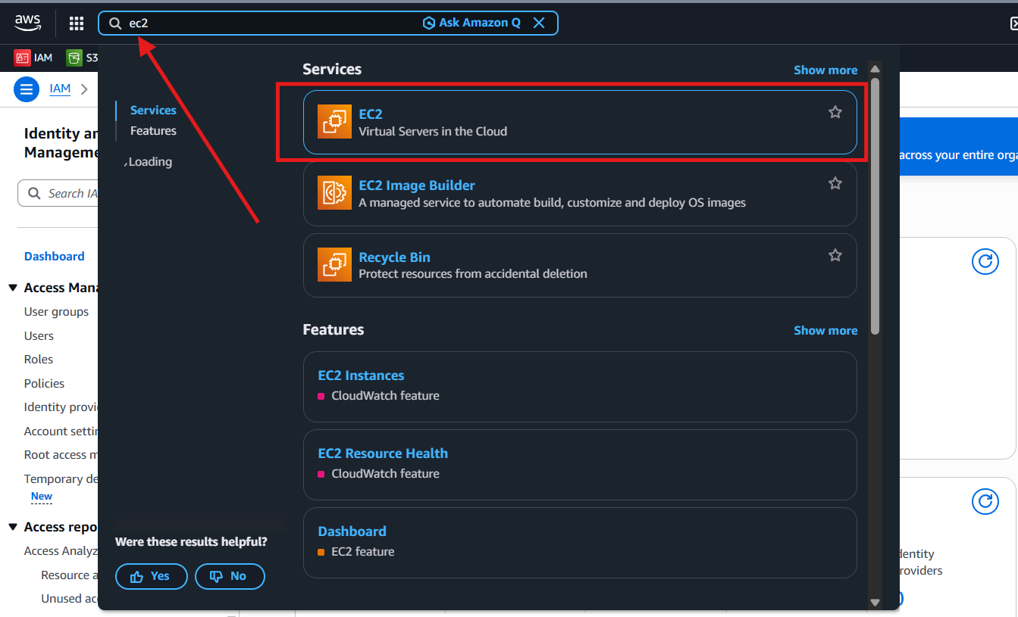
i)Go to Instances
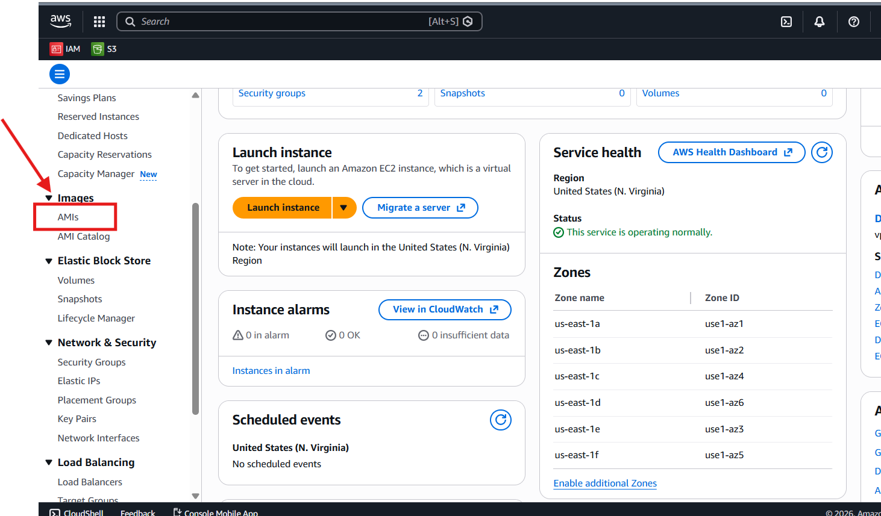

ii)Click on Lunch Instances
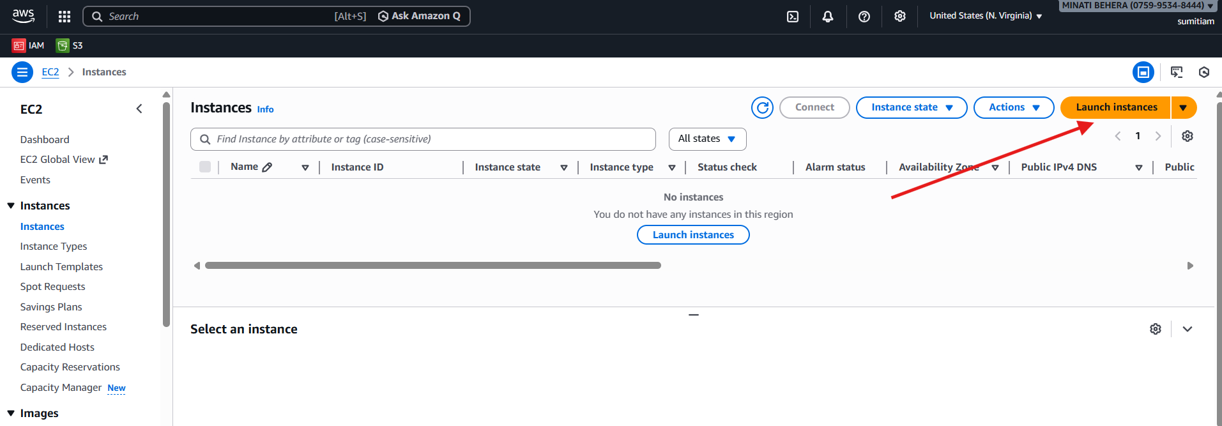
iii)Enter the Name
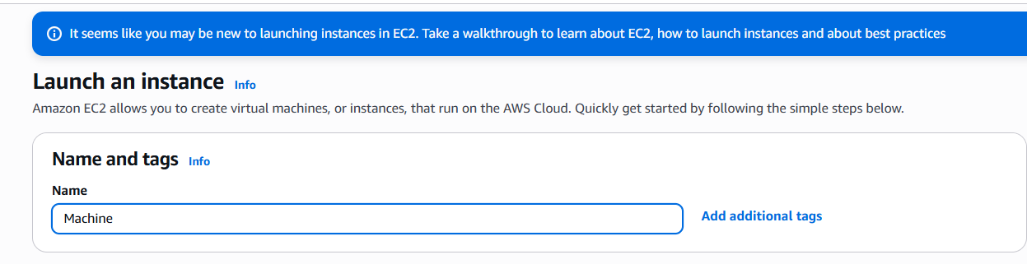

iv)Choose the Os
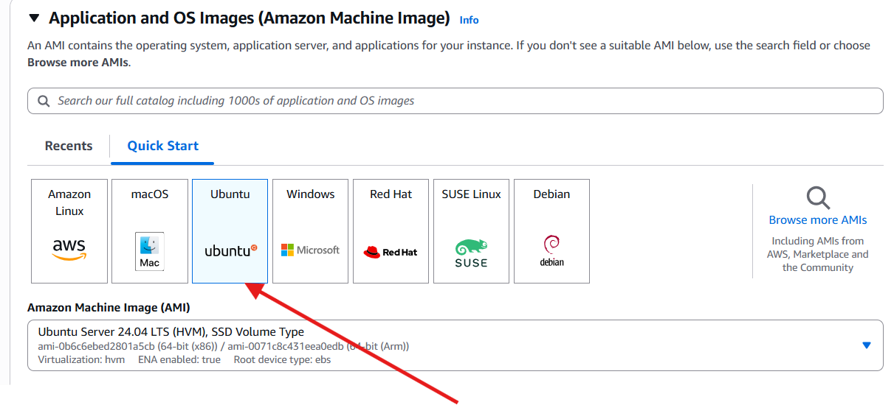

v) Create a key
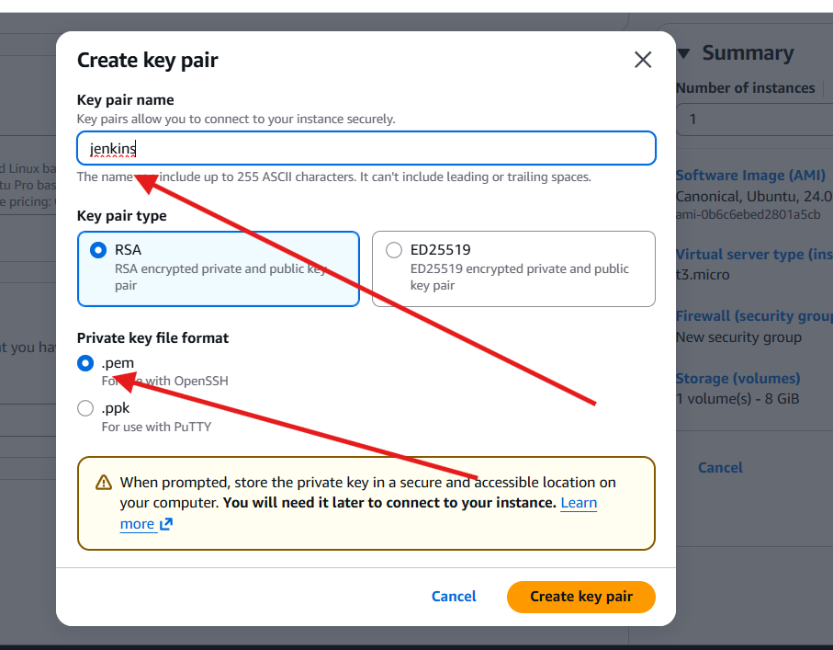

vi)click on Lunch Instance
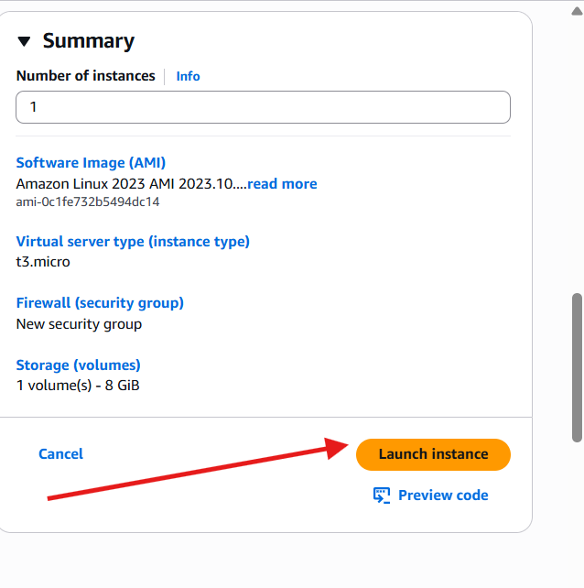
vii)Instance is created Sucessfully

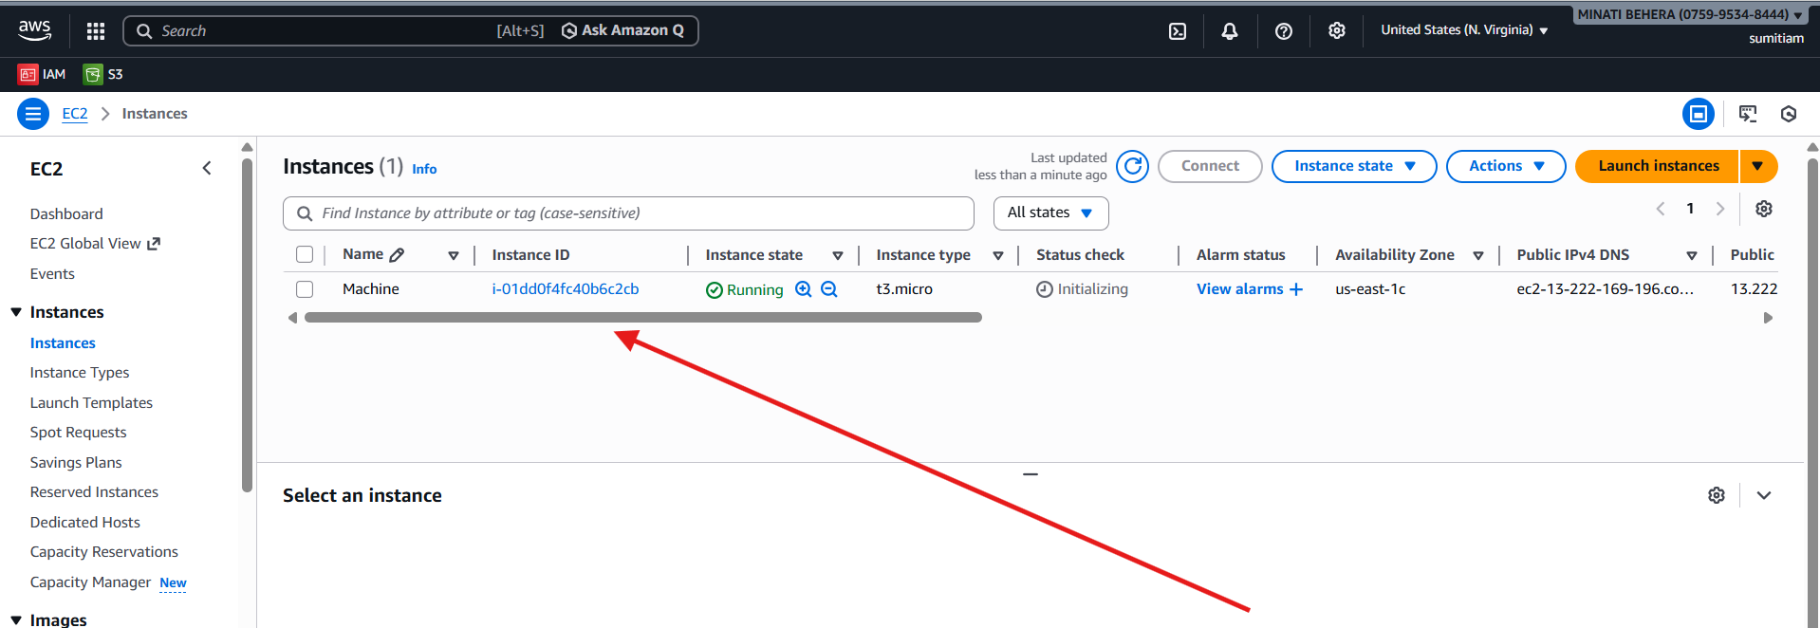

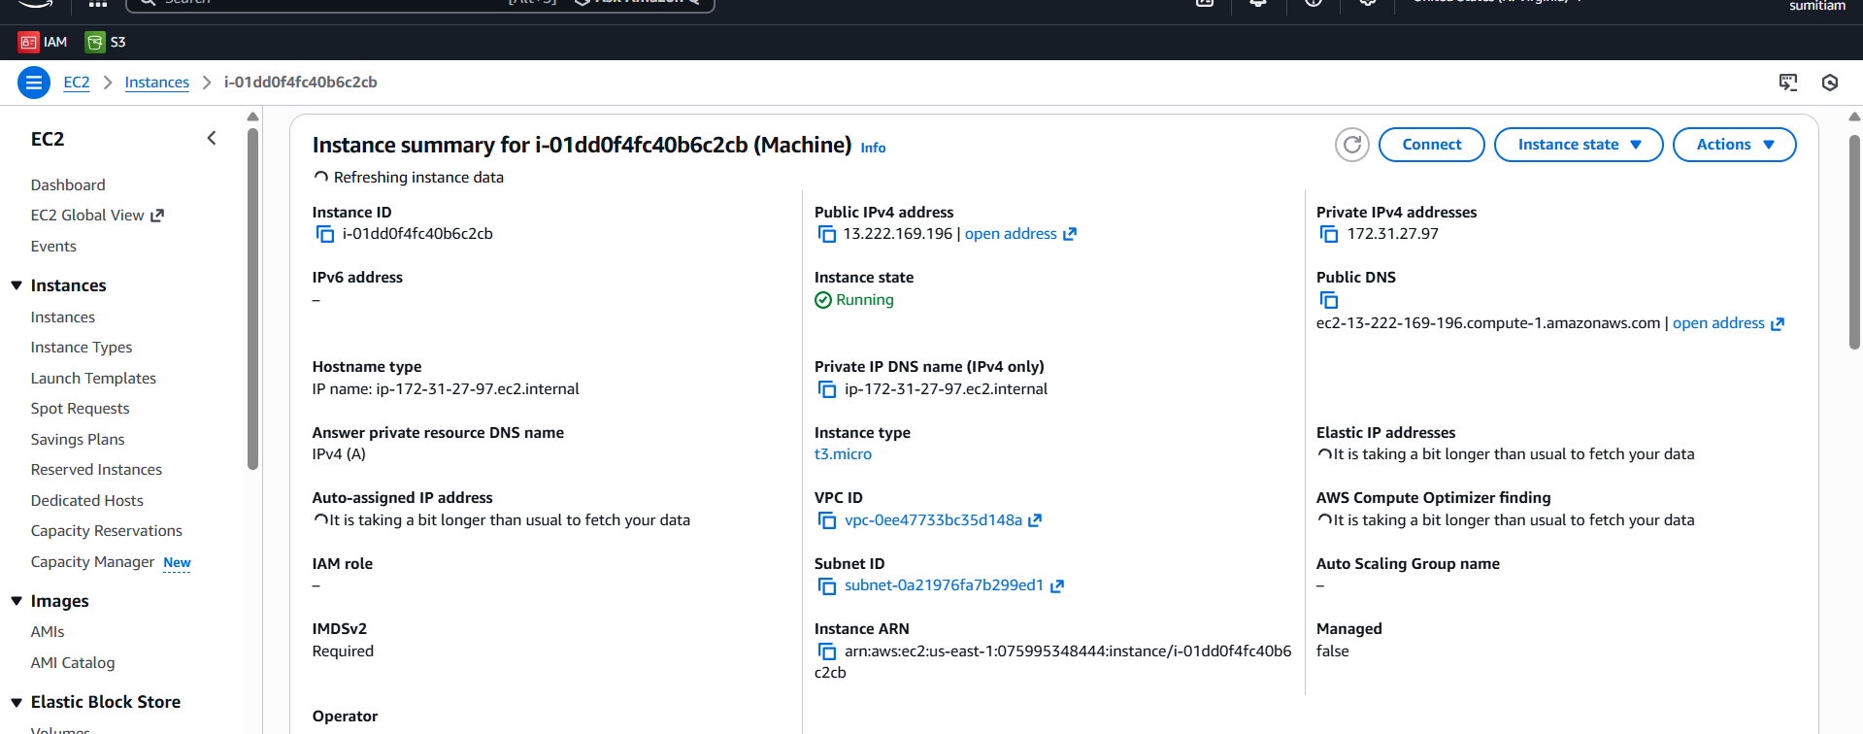
2.Click on the Instance and copy the Ip address

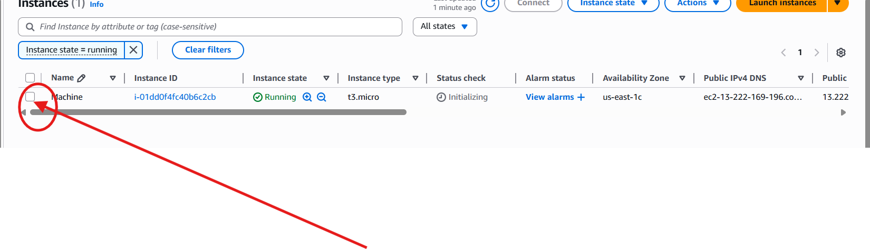
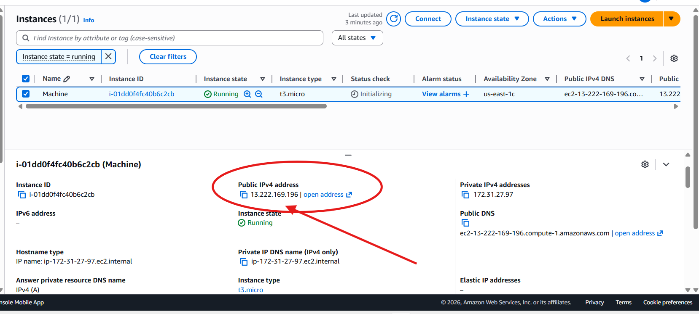

3.Go to the folder where the key file is located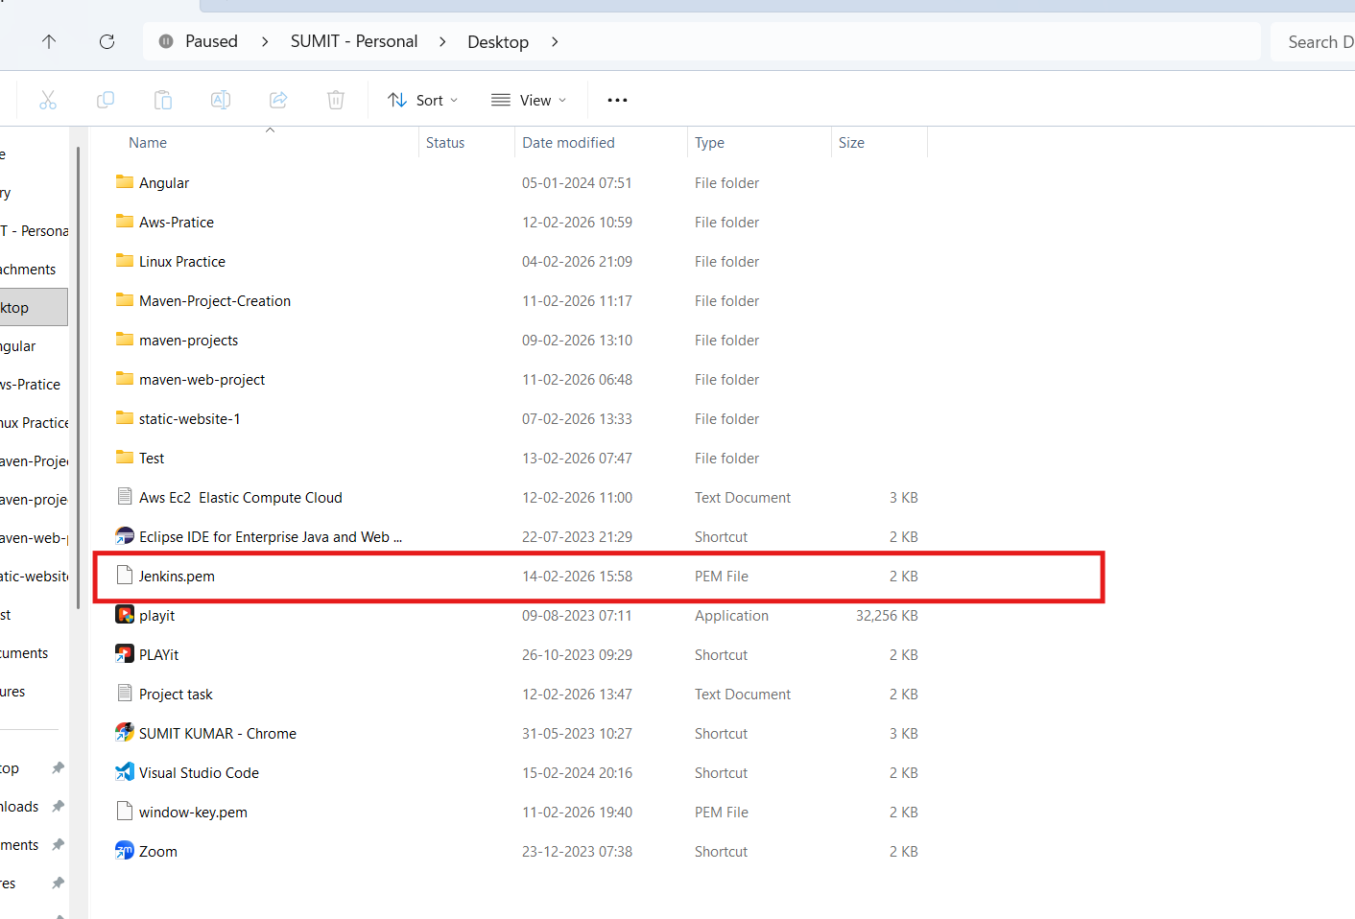
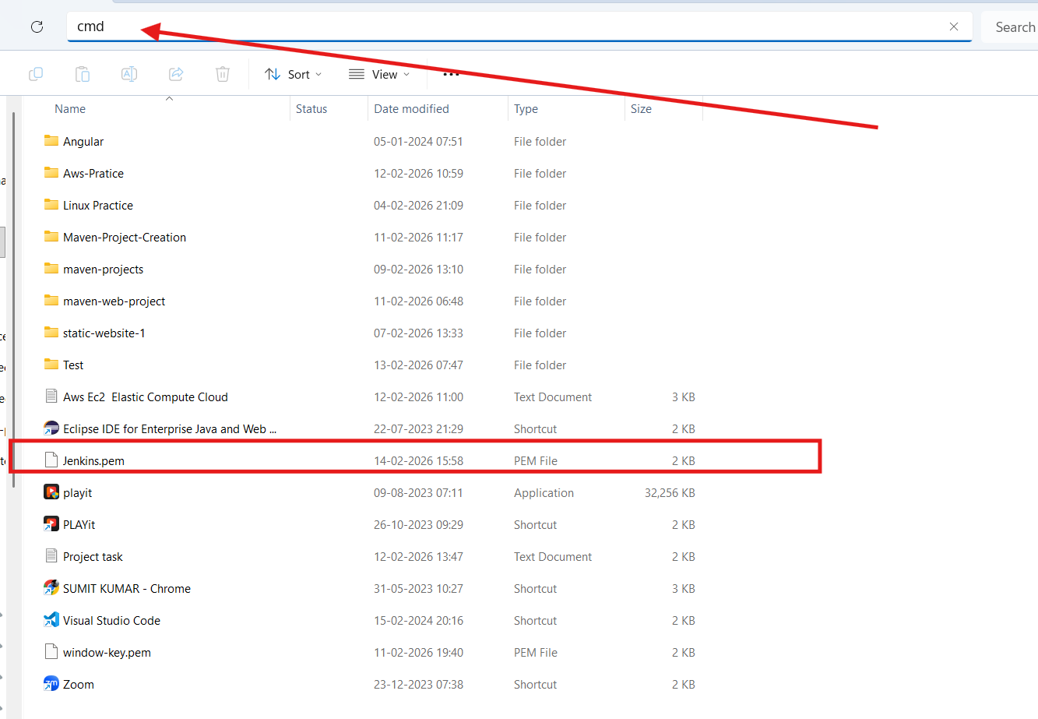

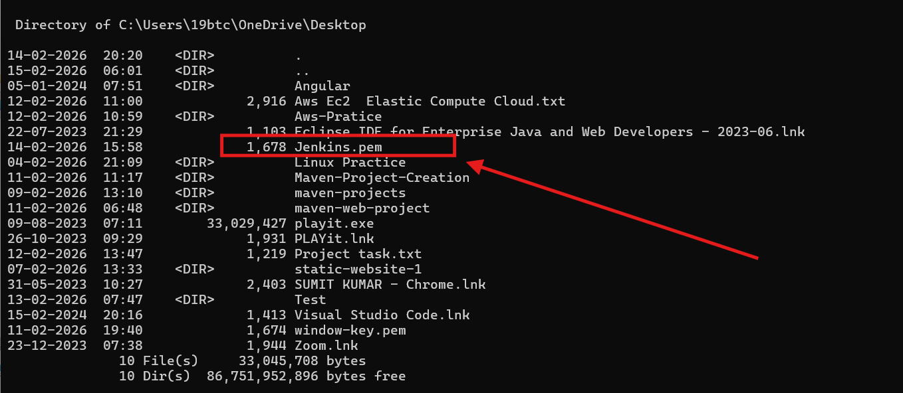
4.Inside command prompt ether the command (ssh -i keyfilename ip )

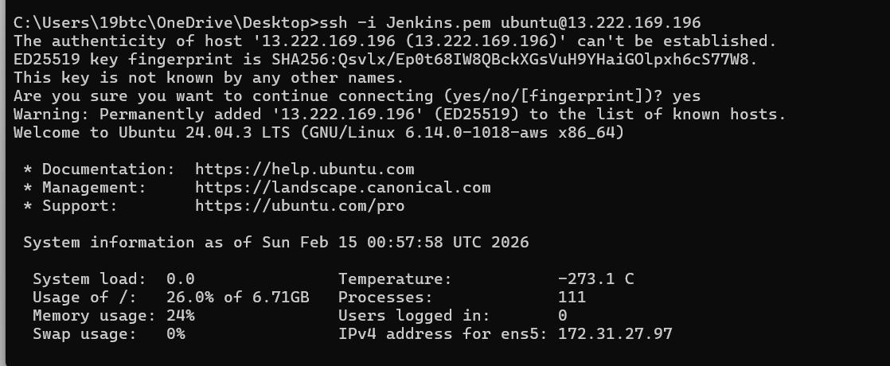
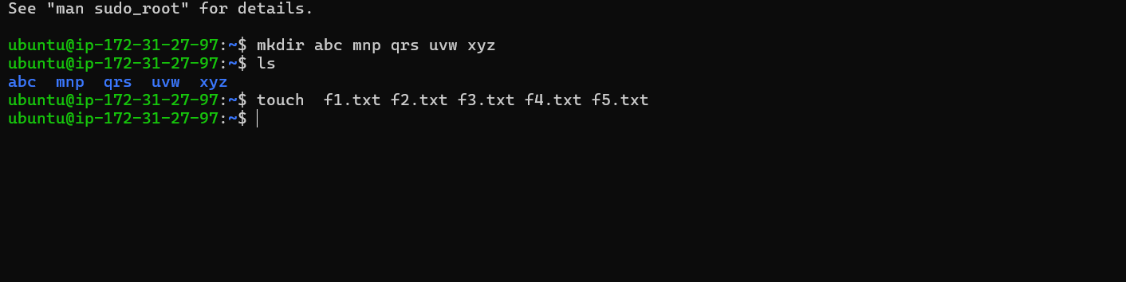

5.Create a image
i) Go to Action
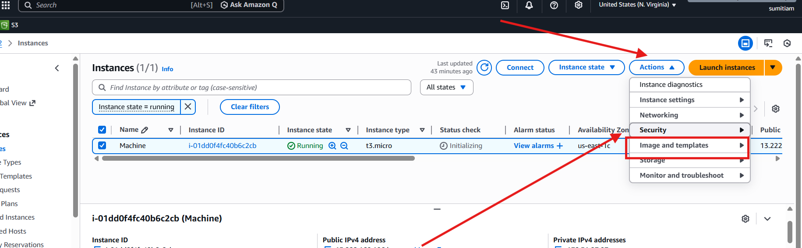

ii)Set the image details

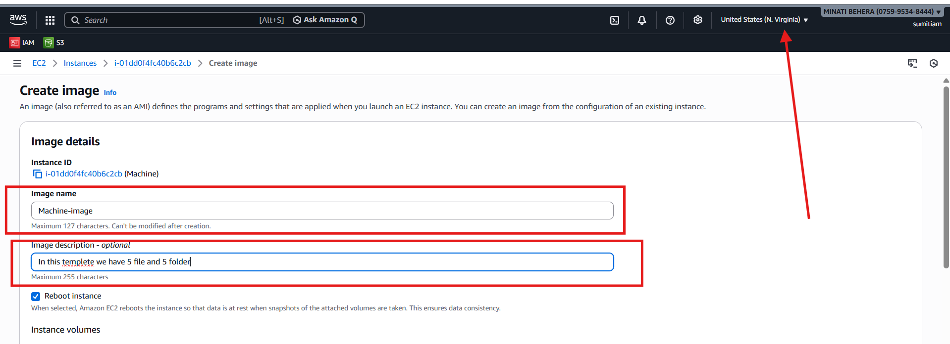
iii)click on create image

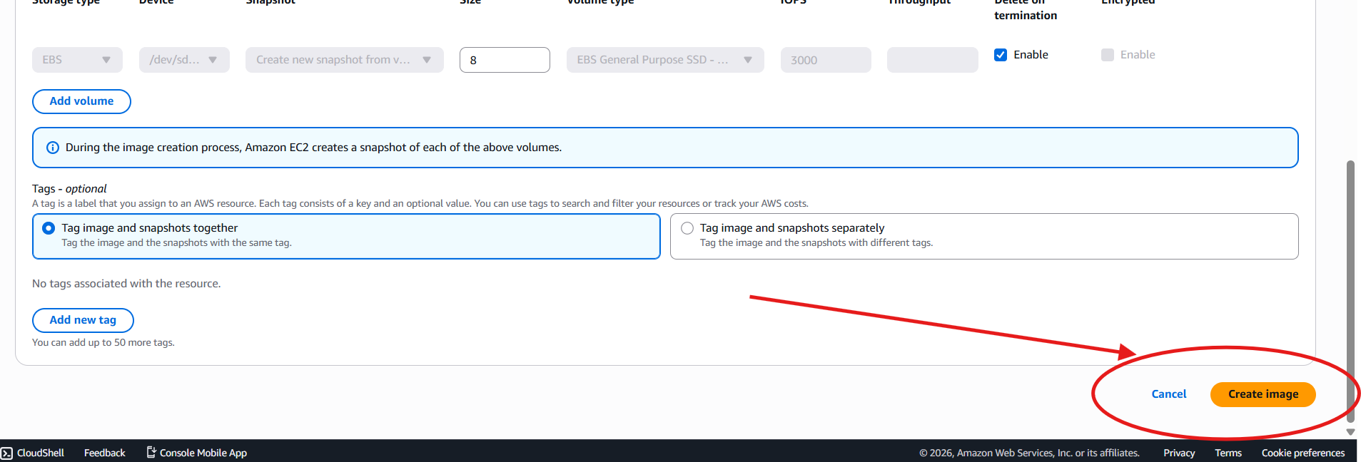

By default our AMI is private we can do it to public as per our requirement

